REVIEW OF INTERNET FUNDAMENTALS

Data is transmitted and received over the Internet through the TCP/IP (Transmission Control Protocol/Internet Protocol) protocols:

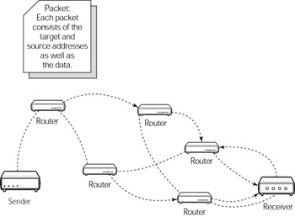

Note: 1) By sender we are referring to the physical machine sending data packets. This may either be the client who is sending a request or the server sending a response. 2) By receiver we are referring to a physical machine receiving data packets. This can again be either the client receiving the response or the server receiving the request.

The following occurs as data is transmitted from sender to receiver:
- The sender breaks data into packets.
- These packets are sent through the Internet to the destination address via routers. Routers calculate the most efficient route for the packet (based on network congestion and traffic) and forward the packet to the next router until the packet reaches its destination.
- The receiver then reassembles the data.

Note: Packets may not travel the same paths to arrive at their destinations. The receiver requests that any lost packets be retransmitted. The job of the sender and receiver is to break up and reassemble packets by using the TCP. The IP is used to forward packets between networks and routers so the packets arrive at their destinations. The TCP/IP protocols are much more complicated than explanations suggest here. This is simply a summary of what happens.

Some examples of higher-level protocols that make use of TCP/IP:
Protocol | Purpose
http:// (HyperText Transfer Protocol) | Used for Web browsing through retrieval of hypertext documents
ftp:// (File Transfer Protocol) | Used for remote file transfers
telnet:// | Used to connect and work on a remote system
News: | Used to read and post messages on newsgroups
SMTP (Simple Mail Transfer Protocol) | Use to send e-mail
https:// (Secure HTTP) | Used for secure transactions (It's an extension of the HTTP)

THE CLIENT/SERVER PARADIGM
The Internet operates in a client/server paradigm. The server operates in a rather passive way. The server waits for somebody to make a request. As a request comes in, the server processes it; then the server waits for more requests or processes subsequent requests.

Server is used interchangeably to describe the program that handles request processing and the physical hardware on which the program runs.

The client is a type of user agent that a user runs to access the Web. A browser is also a type of user agent. There are, however, other types of user agents, such as search-engine robots or chat/messenger programs. The client makes requests to servers and renders the resulting data in a manner that varies depending on the type of user agent . For example, a browser takes the resulting HTML and renders a Web page. A typical scenario of the client/server paradigm is shown in the following figure.

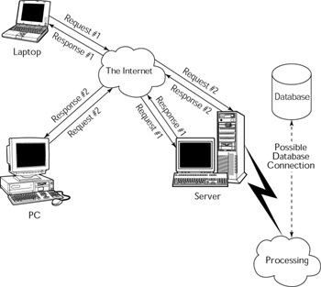
The following steps take place when the client makes a request for a Web page:
- A client (a PC in the preceding scenario) makes a request through the Web browser.
- The server listens on a socket and port for incoming HTTP requests. Port 80 is the default port on the server on which HTTP requests are accepted.
- The server processes the request in the order in which the request arrives.
- The server transmits a response (most likely in HTML).
The client receives the response, and the view is rendered in the browser.

HTTP PROTOCOL

HTTP is the primary protocol for Web pages. It is a connectionless protocol, meaning no permanent connection is retained between the client and the server. An HTTP client/server interaction consists of a single request/reply interchange. The following figure shows the syntax of an HTTP request. It consists of a request line, one or more optional request header fields, and an optional entity body. The lines are separated by a carriage-return/line-feed (crlf). The entity body is preceded by a blank line. Here are the details:

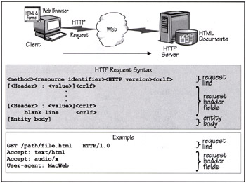
- The request line consists of three text fields, separated by white spaces. The first field specifies the method—or command—to be applied to a server resource. The two most common methods are: GET, which asks the server to send a copy of the resource to the client and POST, which lets a client send a form's data to the specified URL. The second field specifies the name of the target resource; it's the URL stripped of the protocol and server domain name. The third field identifies the protocol version used by the client; for example, HTTP/1.0.
- The request header fields pass additional information about the request, and about the client itself, to the server. The fields act like RPC parameters. Each header field consists of a name, followed by a colon (:) and the field value. The order in which you transmit the header fields is not significant.
- The entity body is sometimes used by clients to pass bulk information to the server.
The following figure shows the syntax of an HTTP response. It consists of a response header line, one or more optional response header fields, and an optional entity body. The lines are separated by a carriage-return/line-feed (crlf). The entity body must be preceded by a blank line. Here are the details:
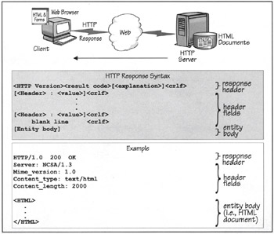

- The response header line returns the HTTP version, the status of the response, and an explanation of the returned status.
- The response header fields return information that describe the server's attributes and the returned HTML document to the client. Each header field consists of a name, followed by a colon (:) and the field value. The order in which the server returns the header fields is not significant.
- The entity body typically contains an HTML document that a client has requested.

CLIENT-SIDE SCRIPTING
Client-side scripting allows a developer to control events and responses (to a limited extent) on the client side of the Internet's client/server paradigm. The most widely supported scripting language on all browsers is JavaScript. VBScript is another popular option; however, VBScript is supported only in Microsoft's Internet Explorer.
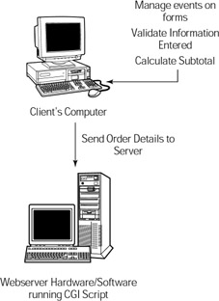

SERVER-SIDE SCRIPTING
The more interesting part of Web-applications development is what happens on the server side. This is where the action is! Server-side scripting or programming can be used very effectively to provide interactivity and dynamic content for a client.

Let’s look at how to publish a Web page and see what happens to HTML pages:
- Author writes HTML pages
- Client requests a Web page from the browser
- The server locates the Web page
- The server sends the page back across the Internet to the browser
- The browser processes the page

What happens to Web pages with server-side scripts?
- Author writes the Web pages with server-side scripts
- Client requests a Web page from the browser
- The server locates the Web page
- The server interprets the instructions provided in server-side scripts to modify the page
- The server sends the page back across the Internet to the browser
- The browser processes the page

Scripting options

- Common Gateway Interface (CGI)
- Hypertext Preprocessor (PHP)
- JSP/Servlets
- ASP.NET

PHP

PHP stands for Hypertext Pre-Processor. As is suggested by the name, PHP is a pre-processor for hypertext. Being a pre-processor, PHP runs on a remote Web server to process a Web page before it is loaded in a browser. Despite its powerful features, PHP is quite a simple language that has been designed specifically for developing and working with Web pages. Its syntax is similar to that of C and Perl. However, knowledge of both of these languages is not a prerequisite for getting started with PHP, so you can rest easy. It is an open-source software and can be downloaded for free.
One of the foremost reasons for the success of PHP, in addition to other factors such as simplicity and powerful features, is its low entry barrier. Even non-programmers or starters can create their Web sites with ease by using PHP. This probably explains the existence of over five million PHP-based Web sites on the Internet.

WHAT DO YOU NEED TO RUN PHP PAGES?
PHP can be used on any operating system, including Microsoft Windows, Mac OS, Linux, HP-UX, and Solaris. In addition, you can run PHP in any software combination. Installation software can be downloaded at http://www.php.net/
HOW DOES PHP WORK?
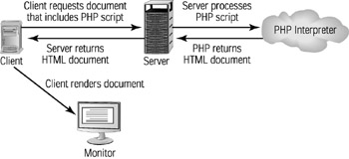
Create your first PHP page

- To edit the source code of your ASP.NET pages, choose a text editor
  - Notepad
  - Allaire HomeSite
  - Any text editor

- FTP your finished pages to your ECT account.
- To view your finished page: open a web browser and use a URL in the following form:
http://ectweb.cs.depaul.edu/YOUR_ECT_LOGIN/PATH_AND_FILENAME

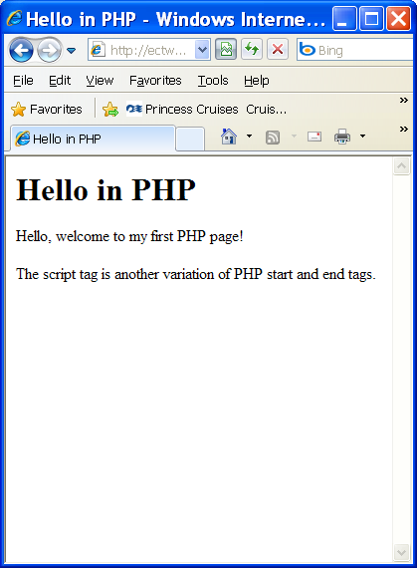 | Basics/hello.php  <html>  <head>  <title>Hello in PHP</title>  </head>  <body>  <h1>Hello in PHP</h1>  <?php  print "Hello, welcome to my first PHP page!";  ?>  <script language="php">  echo "<P>The script tag is another variation of PHP start and end tags. </P>";  </script>  </body>  </html>

PHP Start and End Tags
The PHP parser recognizes a few types of PHP start and end tags. It will attempt to execute anything between these tags, so it had better be valid code!
Opening Tag | Closing Tag
<?php | ?>
>script language="php"> | </script>

